** Can Joy Smell Parkinson’s Disease?**

Begin by watching the video posted on

Canvas at

<https://www.youtube.com/watch?v=e3RlYHahcMw>

Joy Milne participated in a study where she was given 12 t-shirts, half of which were worn by Parkinson’s patients, and half of which were worn by a control group. Joy correctly identified 11 out of the 12 shirts. Does this provide ***convincing*** evidence that Joy can smell Parkinson’s?

1. Why would it be important to know that someone can smell Parkinson’s disease?

It is important to know if someone can smell Parkinson’s disease because being able to detect or smell Parkinson’s before the tremors begin would help researchers and doctors further the research into a cure for Parkinson’s.

2. How many correct decisions would you expect Joy to get out of 12 if she really couldn’t smell

Parkinson’s (she was just guessing)? Explain.

I think she would get about 6 if she was guessing, because if someone is guessing, there is a 50/50 chance they will get it right.

3. Do we have some evidence that Joy can smell Parkinson’s? Why?

Yes, when Joy took the test, when she was smelling the shirts of the participants, she said that someone in the control group had the smell of Parkinson’s disease before they were actually diagnosed 6 months later.

4. How many correct decisions out of 12 would it take to *convince* you that Joy really could smell

Parkinson’s?

It would take eleven out of twelve to convince me that she could smell Parkinson’s.

Let’s investigate whether Joy’s result could have happened purely by chance, just by guessing. Using an applet, you will simulate this study. You pretend to be Joy, using the applet to record your guesses.

Access the applet from the link posted on Canvas at <https://www.stapplet.com/parkinsons.html> .

4. Make your guesses and record your result from the applet:

|  |  |
| --- | --- |
| Correct | Incorrect |
| 6 | 6 |

5. Now let the applet repeat the process 29 more times for a total of 30. Copy the dot plot here.

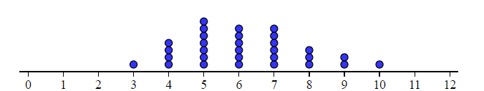

6. What does each dot represent?

Each dot represents a correct guess.

7. Based on your 30 simulations, what proportion resulted in 11 or more correct identifications?

0%

8. Based on these results, do we have convincing evidence that Joy can smell Parkinson’s? Explain.

Yes, because if she couldn’t smell Parkinson’s disease, as the data suggests, there would be a high likelihood that she would have correctly identified 10 or less shirts.